Exmouth and the Royal Marines

The formation of the Royal Marines can be traced back to 1664 when 1200 soldiers were recruited for service in the Fleet. Known as the Admiral’s Regiment these men and their successors were not only soldiers but also seamen and part of the complement of all warships.
The Marines were the only long service troops in the 17th and 18th century Navy, fighting both on land and at sea and maintaining discipline on the ships. Some 2700 Marines took part in the Battle of Trafalgar in 1805.
By the outbreak of war in 1914, Britain had the largest fleet in commission in the world, with all ships above that of destroyer size having Royal Marines detachments.
During World War Two some 80,000 men served in the Royal Marines, and in 1942 the first Royal Marines Commandos were formed.
Few ships now have Marines permanently aboard but parties of Marines join ships as necessary and can be quickly deployed by helicopter or small craft.
The Commando Training Centre at Lympstone has been training Royal Marines since 1939.

Colour Sergeant Leonard Dyble
Leonard Dyble joined the Royal Marines in 1918 just as the First World War was ending.
Throughout the next 21 years he kept a record of the ships on which he served and the places he visited and the Museum exhibits an album containing photographs taken by him. He served on some ten ships during that period.
His regular service was due to end in 1939 but by that time the Second World War had started. He re-enlisted and continued to serve in the Marines until September 1945.
As well as the album we also display part of his ceremonial uniform.
His last ship prior to his re-enlistment was the Revenge Class battleship HMS Royal Oak.
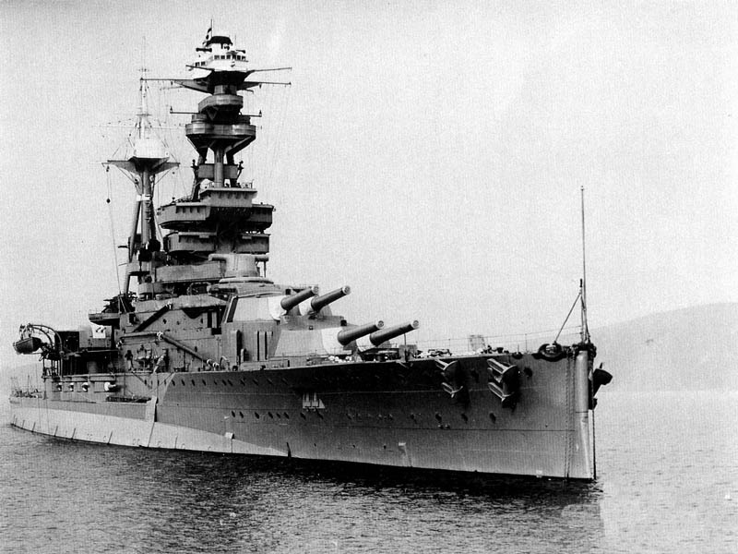
HMS Royal Oak

On 14th October 1939 she was torpedoed whilst at anchor in Scapa Flow with the loss of 833 lives, some two-thirds of her crew. Leonard could well have been one of those fatalities if he had not transferred ships on re-enlistment.
He survived World War II and spent his final years in Exmouth until his death in 1992.

